1. Connected old inventory to orders and purchases

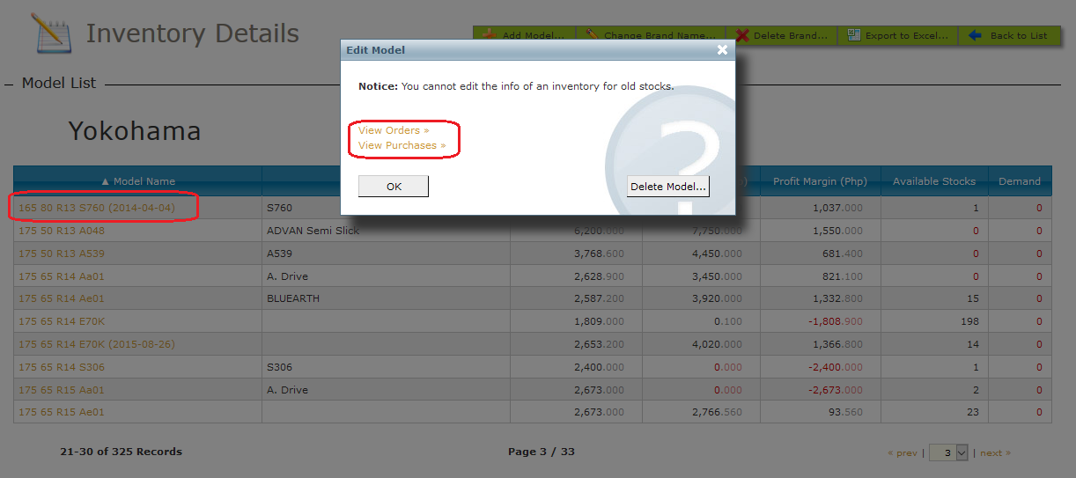

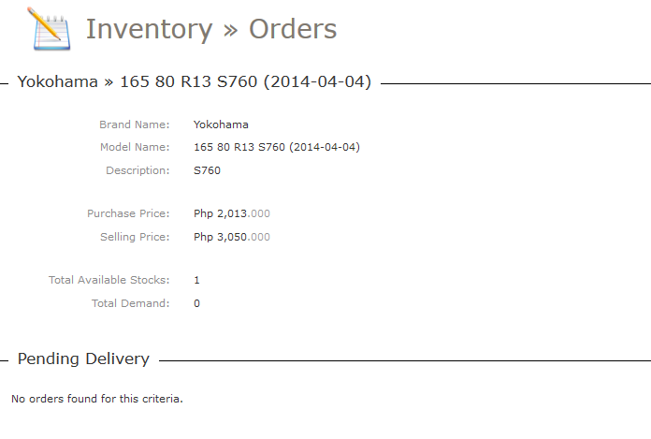

2. Fixed bugs

\* Details are lost when editing orders and purchases

\* Cannot edit customer

\* Inconsistent reserved count of inventory

\* Cannot export inventory to Excel

\* Export to Excel of agents is hanging

\* Export to Excel progress message does not close automatically

\* Cannot reset customer form

\* No prompt to change initial password

\* Other under the hood bug and code fixes